NCR Aloha Cloud POS

Understanding Cloud Icons and statuses

The POS system enables you to quickly determine the connection status of a device through the use of a cloud icon in the POS app. The cloud icon appears on every screen. The color of the cloud icon indicates the device connection status. When you tap the icon, a connection drop-down menu appears indicating the specific state of the device connection to the host computing system, the server, and to the credit processor.

Additionally, you can initiate a series of actions from the connection drop-down menu, such as synchronizing data with the host computing system, putting the device in offline mode, or returning the device to online mode.

The cloud icon is always visible on a device on every screen at the top right. Depending on the connection state, the cloud icon may appear as white, yellow, or red.

Icon Status | Description
 | - Indicates all connections are active and online.
 | - Indicates at least one connection is unstable or unreachable.  - The point of sale app may not be able to connect to the host.
 | - Indicates at least one connection is unreachable.  - There is no Internet connection.

It is possible for one device to display a white cloud icon while another device displays a yellow or red cloud icon. Your location may be a factor to consider if it has poor or no Wi-Fi signal.

The cloud icon color displays the lowest current connection state at the moment. For example, if the device can connect to the host and to the credit processor, but not to the server, the cloud icon appears as red.

When you tap the cloud icon, a connection drop-down menu appears revealing the connection status of the device to the host, the Server, and to the credit processor. Additionally, action buttons to synchronize your device with the host and, if necessary, to put the device into offline mode or online mode appear. You can also tap each connection state to view additional information.

The host status indicates your POS terminal's ability to communicate with the host and synchronize data with the Back Office. This synchronization occurs at least every three minutes.

The following table lists the possible connection states, the corresponding color, the message the POS app displays, and the available action or message.
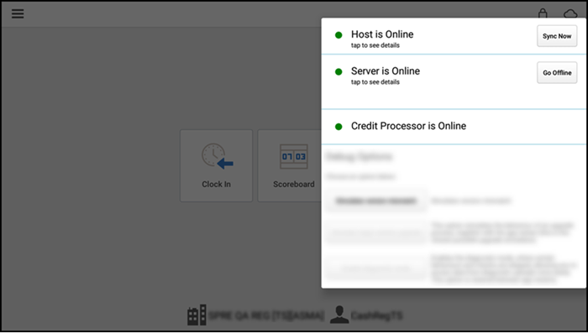

Connection |  | Status Color | Message |  |  | Available Action or Message
Host  (Internet) |  | Green | Host is online |  |  | Action: Data Sync
 |  | Yellow | Host is Offline |  |  | Action: Power cycle
 |  | Red | Host is Unreachable |  |  | Action: Go offline
Server |  | Green | Server is online |  |  | Action: No action
(Macmini | or |  | Server is Unreachable |  |  | Action: Go Offline
Primary | POS
Device) |  | Red | Offline Mode |  |  | Action: No action
 |  |  | Offline | Mode, | Server | Action: Go Online
 |  |  | Reachable
Credit |  | Green | Credit Processor is Online |  |  | Action: No action
Processor
(Status of |  | Yellow | Credit Processor is Offline |  |  | Action: Go Online
Gateway
Software)
 |  | Gray | Credit Processor not initialized |  |  | Action: configure Credit card processor

Connection terminology

Online — Specifies the device as connected to the host, the Server, or to the credit processor. The device can send and receive data to the specified source.

Unstable — Indicates the device as temporarily unable to connect to the host computing system.
Unreachable — Specifies the device as unable to connect to the host, the Server, or to the credit processor. The device cannot send or receive data to the specified source.

Common Issues and Their Causes/Solutions

This document is meant to serve as an initial guide for troubleshooting.
After getting the caller’s name and FC number (shop number), we will look for the store in Scale and NCR. Sometimes, the client will say, "My screen is not working." Consider that the shop has many screens, so it is important for us to ask more questions about it, such as, "Where is your screen located?" and "When you say it is not working, do you mean it is flickering?" Is it not displaying any image? Where is the device located? Consider the screens we have are:
- Menu boards on the counter and drive-thru (SageNet).
- POS screens (NCR)
- Timer screens (DTiQ).

During calls with franchisees, we ask about the status of other devices to prevent issues and inquire about their usage of the remaining devices. Sometimes they wait too long to request a replacement.

In the back office, check how many devices they have and ask what is happening.

Verify when they changed their device and what issues they had. They might not be using a device due to issues with it.

If the issue is related to payments, follow up via phone 800-834-4405. We can contact Quincy and CC him so he can solve the issue quickly.

Viviana is the account manager.

Include in the ticket notes if the device is an damaged replacement.

Broken devices must be escalated. Devices with physical damage cannot be replaced. Hardware issues are covered, but if the screen is cracked or if it was damaged by personnel, it is not covered.

When an issue is important, we should CC the FBC in the email.

Follow these steps for troubleshooting:

- Check the socket.
- Check that the power cable is plugged in.
- Make sure the Ethernet cable is plugged directly into the LAN port on the bottom of the POS device.
- Verify that it is securely plugged into the wall outlet and that it hasn't come loose.
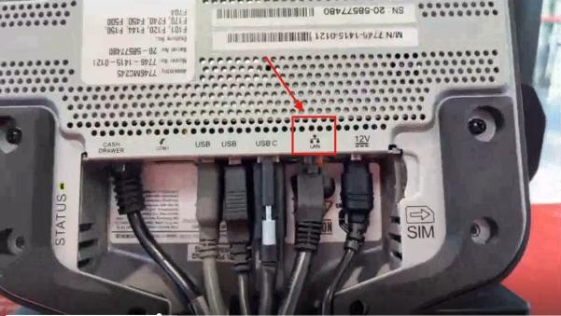

- Do not plug the Ethernet cable into the similarly shaped COM port, as it will not provide an internet connection.
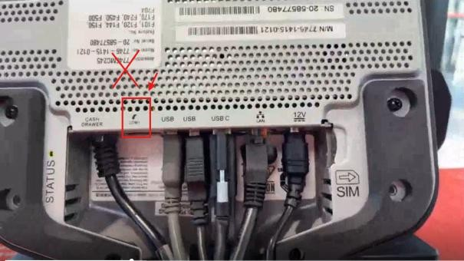

Then, ask them which icons they see in the top right corner of their POS screen.

  - Empty Wi-Fi Symbol: The POS should show this on the top right of the POS, this indicates the POS is connected to the firewall and not the wi-fi directly, which is optimal.
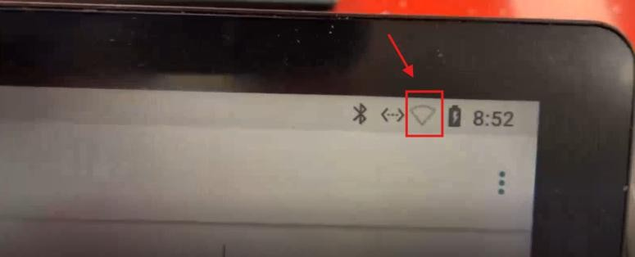
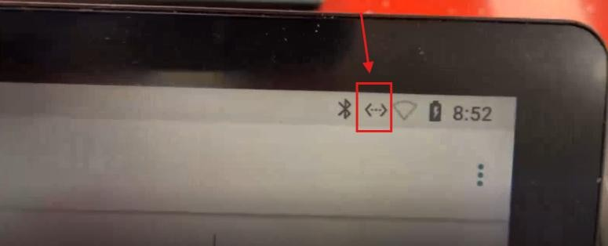
  - Two Arrows: This means the device is connected via ethernet which is optimal.
  - Two Arrows with an Exclamation Point: The Ethernet cable is physically plugged in, but the device needs to be whitelisted in the SCALE system.
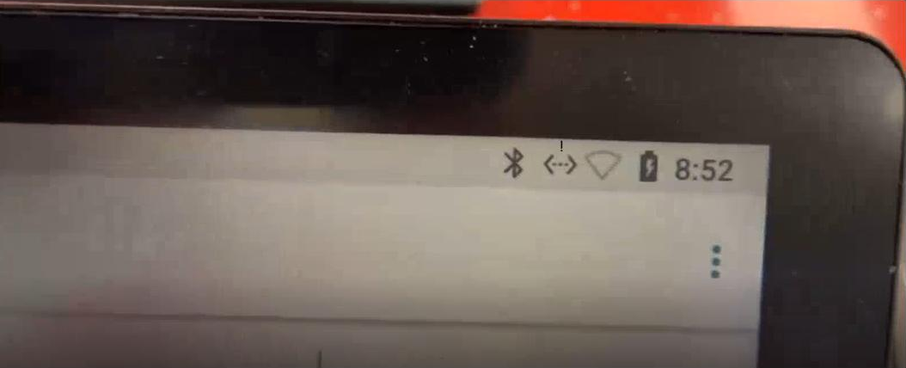

Host is Offline

  - Cause
    - This message indicates that the device is not connected to the firewall.
  - Solution
    - Restart the internet router, then the Accumera box, and finally the Mac Mini or MPOS.
    - Select SYNC NOW next to Host on all the POS devices.
    - Verify that your POS device is not connected to Wi-Fi. If it is, disconnect and restart the device.
    - Initialize the credit card processor.
    - If these steps don't work, have the FC contact their ISP to verify that there is not an internet outage.

Host is Unreachable

  - Cause
    - This message indicates that the device is unable to find and connect to the host.
  - Solution
    - First, confirm with their ISP that the internet is down. If it is not, contact Scale (Acumera) Support at (512)-617-0923 to see if they can help get the device online.
    - In the meantime, there should be an option next to the server that says "Go Offline." This will put the device in offline mode, and the shop can continue to save and store credit card information until the network is back up.
    - When the host is reachable, restart the POS. Press SYNCH NOW next to Host, then go online next to Server.
    - Ask Scale to contact the store after 10 a.m. CT (rush hour) and try to troubleshoot. If this doesn't work, they might need to replace the firewall. Scale will handle this on their end; we just need to confirm the address.

Server is Offline (Most Common)

  - Causes
    - The device is connected to the wrong network, most likely their ISP Wi-Fi. The servers in the Shipley locations are on the Scale (Acumera) network firewall. If a device is connected to a different network, the message "Server is Offline" will display.
    - If only one POS device displays "Server is Offline," then you know that the entire network is not down, which indicates that the device in question is most likely connected to the wrong network.
  - Solution
    - If the shop connected the device to the Wi-Fi instead of the firewall, you will need to show the FC how to forget the Wi-Fi network and connect to the firewall.
      - Press the three bars at the top left of the screen.
      - Go to Settings.
      - Go to Android Settings.
      - Go to Network and Internet.
        - Go to Internet.
        - Select Wi-FI.
        - Turn off Wi-Fi.
      - Restart the POS system.
      - When it turns on again and a pop-up asks you to connect to Wi-Fi, select "No."
      - The device should then connect to the Ethernet (this may take a few minutes after restarting).
      - Check the "Cloud" icon in the top right corner of the screen. Press it, and instead of a Wi-Fi icon, an icon like this should appear: "<.!.>" (two arrows pointing in opposite directions with an exclamation point in the middle).

Server is Unreachable (in all devices but one -MPOS)

  - Cause
    - If all devices show a "Server is Offline" message, then the Mac mini or primary device is not connected to the Internet.
    - We have to verify whether this is an issue in just one POS or a global issue. If it’s a global issue, then it’s usually the MPOS that works as the main server in the store. In the store network, all devices use this server to communicate, so if this server is down, then all the other servers are down. However, this is the only one that can communicate directly with the Acumera box, so it probably shows as online.
    - POS devices that are not MPOS show a yellow or red cloud with the message "SERVER IS UNREACHABLE," meaning they can’t find the main server because it is probably not connected correctly to the network.
  - Solution
    - Check the icons in the top right corner of the screen to verify that they are connected to the network and not the internet.
    - If they are connected to the network but the server is unreachable, then it is an MPOS issue.
    - Ask the FC how many devices they use, and verify on NCR how many devices are working. Sometimes the FC doesn’t use the MPOS much, so it may appear as one that has not been used recently.
    - Verify on SCALE whether only one device is not responding. If so, it is usually the MPOS because the HOST (firewall) is online, but the SERVER (store main server) is not.
    - Verify the switches on SCALE and ask the FC to confirm that everything is plugged in correctly and that there are no loose cables.
    - If SCALE shows an error with the site down, please refer to "HOST IS UNREACHABLE" and perform the troubleshooting steps first.
    - After power cycling the internet router and Acumera box, reset the MPOS and ensure it is correctly plugged into the Acumera box.
    - After restarting, check the cloud status. It should be white again.
    - Check the ports and status on SCALE to confirm that the MPOS is back online.

    - Restart the other two POS devices so that they can recognize the MPOS. If needed, click "SYNCH NOW" next to "Host" and initialize the credit card. The cloud should turn white and all the lights should turn green. This process should take 2-3 minutes, but it varies depending on the internet speed.
    - If this doesn't work and the MPOS/Mac mini switch still shows as black on SCALE, then the issue might be the cable.
    - Ask the FC to use a similar cable. If it works, then the cable is the issue.
    - If the FC doesn't have a similar cable, we can request a replacement cable from NCR. In the meantime, we can change the MPOS to another POS so that it can operate until the cable for the other POS arrives. Then, all devices will be operational.
    - We will send this request to NCR via email. We will explain the troubleshooting we did and request a new cable. If there is physical damage, NCR might be unable to replace it. The FC must send a picture of the issue to our email.
    - The change is performed on the NCR website. Under "My devices," select the POS you want to use as the MPOS.
    - If the issue is with a Mac mini, we might need to escalate it to NCR.
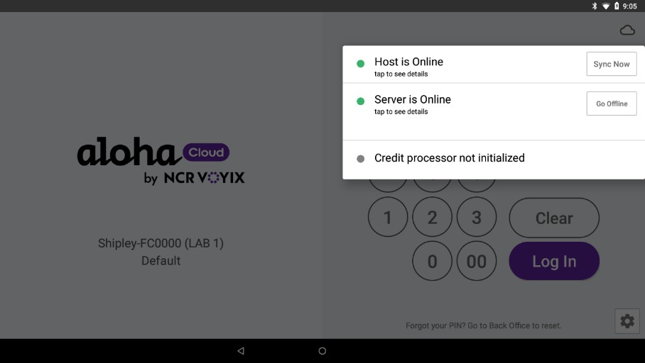

Credit processor not initialized

  - (Go to the guide to initialize a credit processor.)

Understanding online and offline mode

All POS systems must always be connected to the firewall network. If the POS system is connected through Wi-Fi instead of the firewall network through an Ethernet cable, the credit card processing system will only take the card information and accept the transaction without verifying the card's availability. This process is also less secure than connecting via Ethernet.

Devices are in online mode by default. However, when a device loses connection to the server, you can use offline mode to continue operations.

Online mode — Allows you to read and edit orders and shifts created on any device in online mode.

Offline mode — Allows you to read and edit orders and shifts created on the device in offline mode, but only allows you to read orders that were created in online mode. While in the offline mode, the device does not attempt to sync data with the server. The device stays in offline mode until an employee returns the device to online mode. When working in offline mode, one of two status options appear:

  - Offline Mode indicates The device is running in offline mode, and the server is not available.

  - Offline Mode, Server Reachable indicates the device is operating in offline mode, but the server is now available. While in ' Offline Mode, Server Reachable,' orders created on the device in offline mode appear as read-only to a device in online mode. With this status mode, any employee can choose to return the device to online mode and synchronize the data or keep the device in offline mode and return it to online mode later.

Enabling Offline Mode
If the server status color changes to red, it means the device is disconnected from the server. A "Server is offline" prompt will also appear.

To use the device while it is offline, a manager or an employee with the appropriate access level must put the device in offline mode.

While in offline mode, users can still successfully log in, operate the POS, and process credit card transactions.
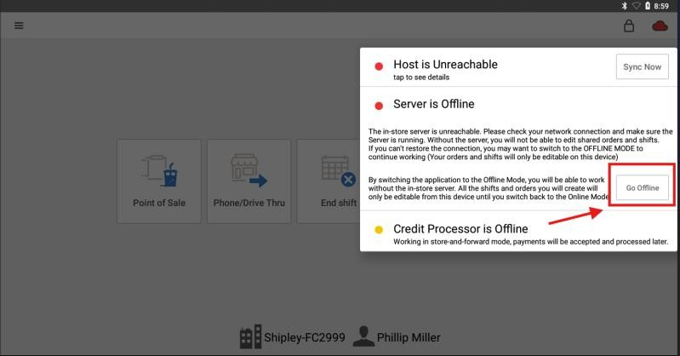

Macmini Troubleshooting
Mac mini troubleshooting is too complicated. If there’s an issue, we might need to move it to MPOS. It is difficult to access remotely.

Device Limit

There is a limit of seven devices. If there are too many devices, we can have issues.

